**User document:**

1. Access the link <http://localhost:4300/home> and choose a book to buy

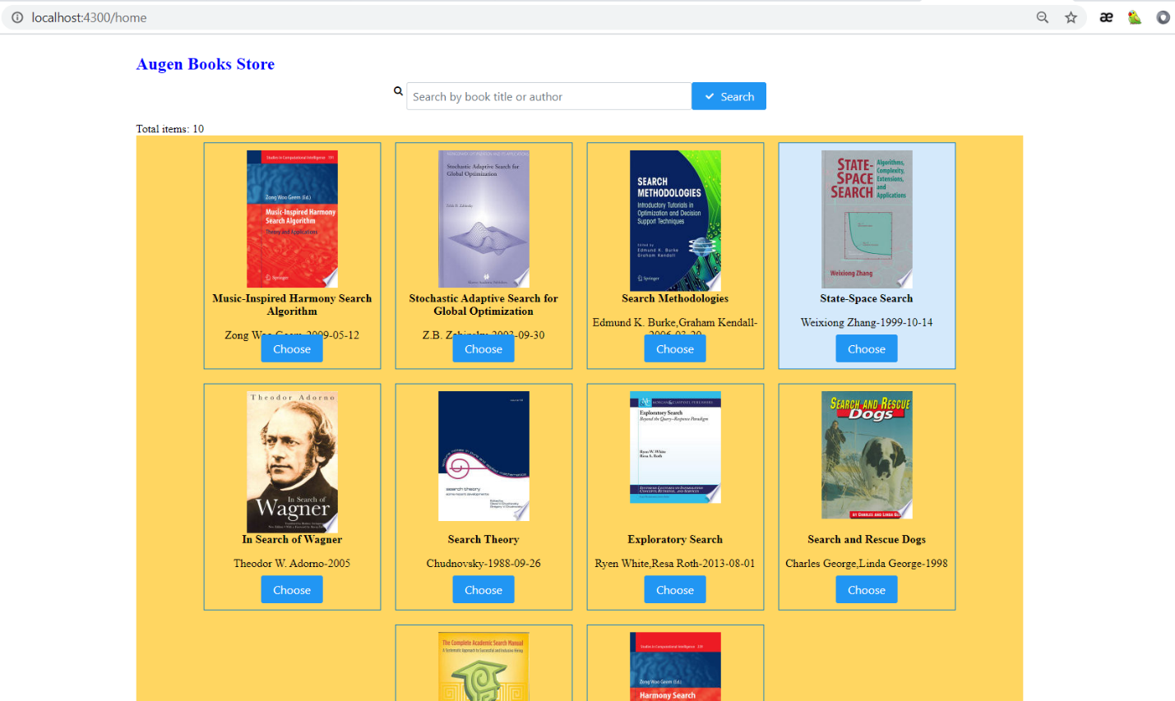

1. Search with title or author

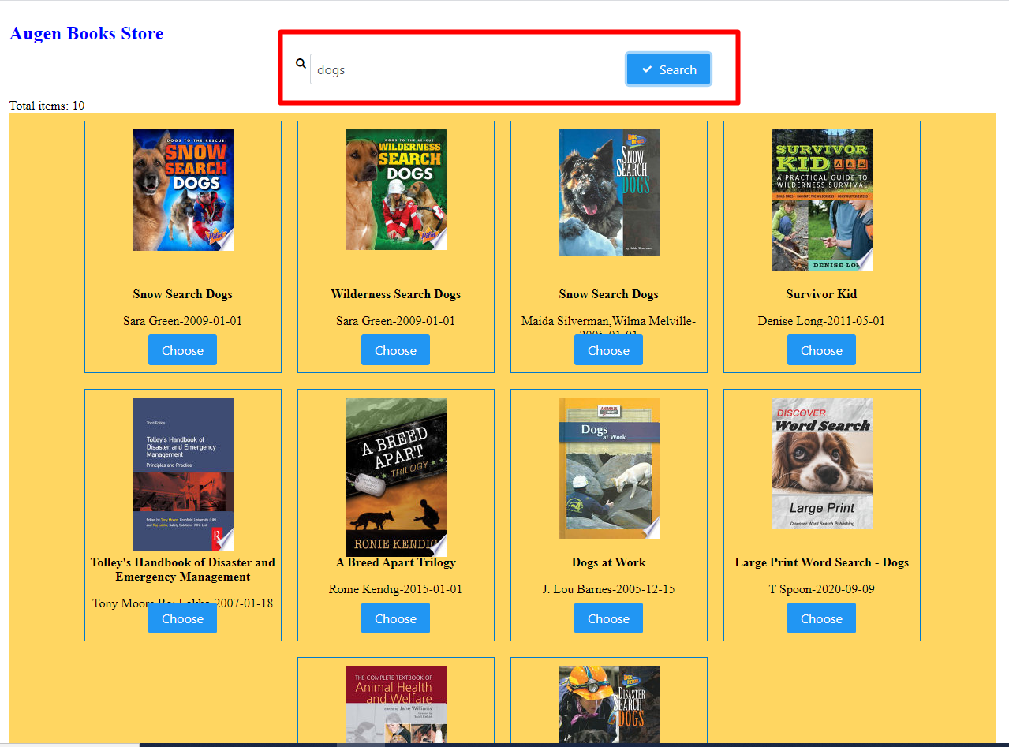

1. Select delivery service and Time and click “BUY” button to confirm

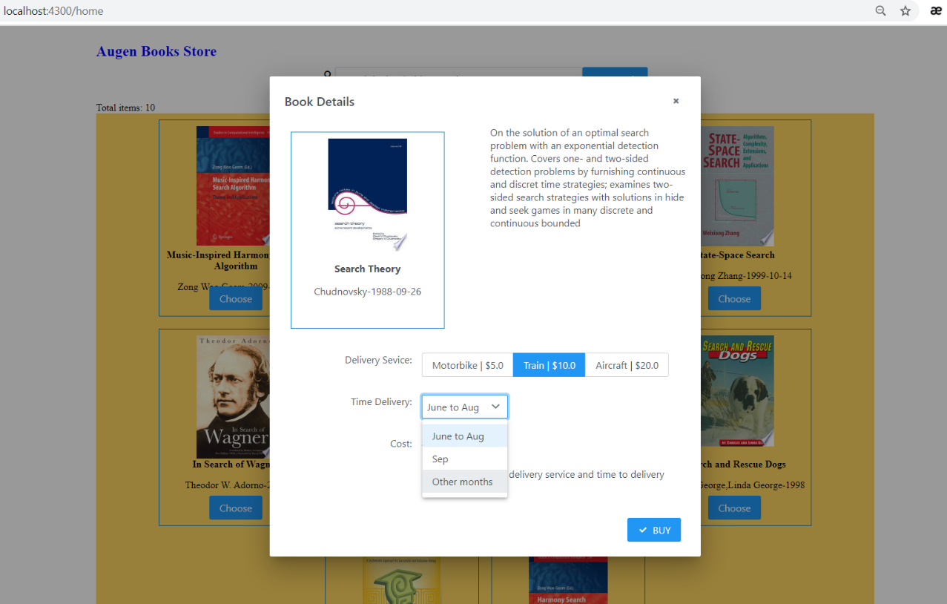

1. See the confirmation and click to “Continue to Buy” to back to homepage.

